Making Models Worksheet

You’ve probably seen diagrams of the solar system before in science. A diagram is an example of a scientific MODEL, which is a representation of a complex object or process. A model can be useful in providing information when people can’t actually observe an object or process directly. Yet, often there is information missing from a model. The reason for the missing information is that a model is often made for the purpose of representing one specific characteristic of an object or process. Therefore, other characteristics are not so important for the specific purpose of the model.
Consider Model A and Model B. Both are models of the solar system that show the sun and the planets (and dwarf planets) that revolve around the sun. Despite these similarities, the two models are quite different. The reason that they are different is that they were made with different purposes in mind.

- What is a scientific model?

- Why is information often missing from a model?

MODEL A:
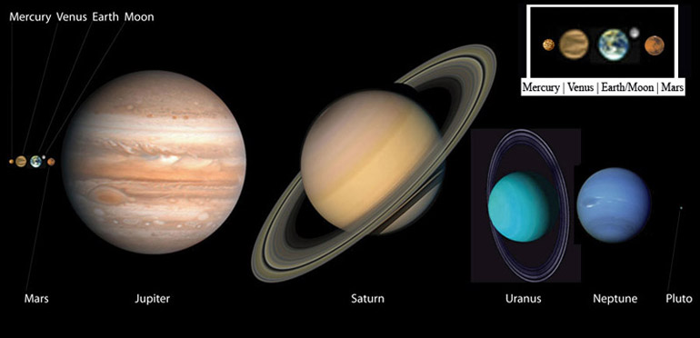

- What does Model A show about the solar system?

- What information is missing from model A?

MODEL B:
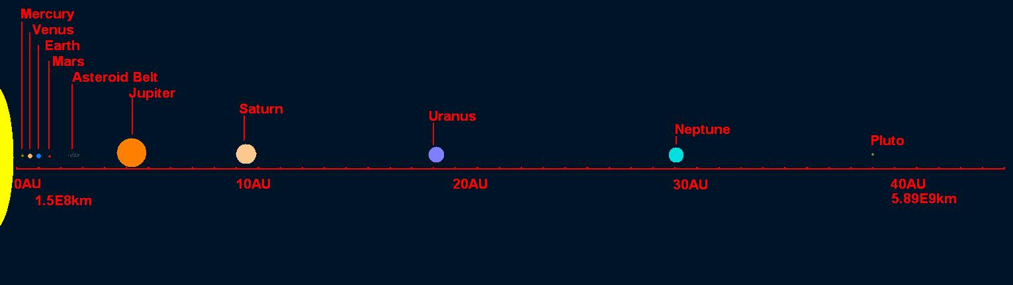

- What does Model B show about the solar system?

- What information is missing from Model B?

- Are both models important, and why?

