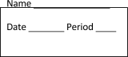
Think Like a Scientist – Skills – Review sheets
DEFINE these vocabulary terms in your own words (you may use your resources):
Observe

Qualitative Observations
Quantitative Observations
Inferring

Prediction

Classify

Make models

WRITE one vocabulary word from above next to each example:
Example | Thinking Skill
- Sarah groups the flowers she sees into categories based on what they look like.
- Sarah observed that there were 22 flowers in the garden.
- Sarah noticed some caterpillars on some of the leaves and decided that was how the leaves got holes in them.
- Sarah sketched a diagram of each flower in her notebook.
- Sarah saw on the news that the next week was not going to have any rain, and she guessed that the flowers may get very dry.
- Sarah observed that the flowers smelled very sweet and fragrant.

MAKE 3 of each type of inference
MAKE 2 inferences
MAKE 2 predictions
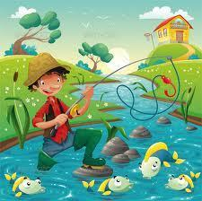
Qualitative | Quantitative
1)  2)  3) | 1)  2)  3)
Make inference:

Make a prediction:

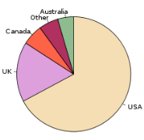
ANSWER the questions about the graph – MAKE a prediction
- What country eats the most strawberries?

- Do you think this graph would look different in January?
Why or why not?

CLASSIFY these animals into categories – make sure you don’t make an “other” category and every animal MUST be included:

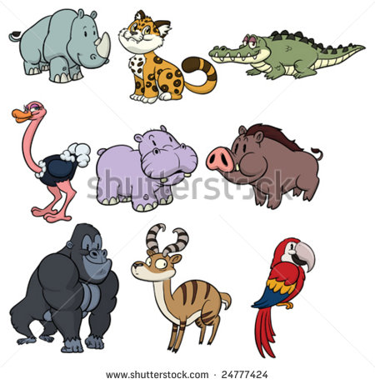

Skill | Example from your real life | Why this skill is important to scientists
Observing
Inferring
Predicting
Classification
Making models

